SKILL ENHANCEMENT LABORATORY: GENERATIVE AI
Experiment 1 – Multimodal Generative AI

1. Aim
To use Generative AI tools to create a short story, an image, and a 15–30 second sound/music clip based on a common theme, and to analyze how well the outputs align while discussing the strengths, limitations, and ethical challenges of multimodal Generative AI.

2. Theme
A Journey to Mars

3. Tools Used
- Generative AI text-generation tool
- Text-to-image generation tool
- AI music/sound-generation tool
- Internet connection

4. Procedure
Step 1 – Select a common theme: A common theme was selected so that the text, image, and sound could be compared. The selected theme was “A Journey to Mars.”
Step 2 – Generate the text: A Generative AI text tool was used to create a short story about an astronaut exploring Mars and discovering something unexpected.
Step 3 – Generate the image: A text-to-image Generative AI tool was used to create a visual representation of the same Mars exploration theme.
Step 4 – Generate the sound/music: An AI music-generation tool was used to create a 20-second cinematic science-fiction background soundtrack representing mystery, exploration, discovery, and inspiration.
Step 5 – Analyze the outputs: The story, image, and sound were compared to determine whether they represented the same theme and emotional progression.

5. Text Generation
Prompt Used
Write a short imaginative story of about 150 words about an astronaut named Arjun who travels to Mars for the first human research mission. Describe the Martian landscape, his emotions, and his discovery of something unexpected. Use a futuristic and inspiring tone.
Generated Story
The First Step
Arjun stepped out of the spacecraft and became the first human to walk across an unexplored region of Mars. The red landscape stretched endlessly beneath the pale sky. Every step raised tiny clouds of dust that floated silently in the weak Martian gravity.
His mission was to search for signs of ancient water. After several hours of exploration, his scanner suddenly detected something unusual beneath the surface.
Arjun carefully removed the layers of Martian soil and discovered a strange crystalline structure. It was unlike anything scientists had seen before. The crystal emitted a faint blue glow and appeared to contain perfectly organized patterns.
As Arjun transmitted the discovery to Earth, he looked toward the distant mountains. He realized that humanity's journey to Mars might not simply be about exploring another planet—it might be the beginning of discovering an entirely new chapter in the history of the universe.

6. Image Generation
Prompt Used
Create a cinematic realistic image of a lone astronaut standing on the surface of Mars, surrounded by vast red mountains and rocky terrain. Show Earth as a tiny blue planet in the distant sky. The astronaut should be examining a glowing mysterious crystal partially buried in the Martian soil. Futuristic spacecraft in the background, dramatic lighting, highly detailed, realistic science-fiction style.
Generated Image:
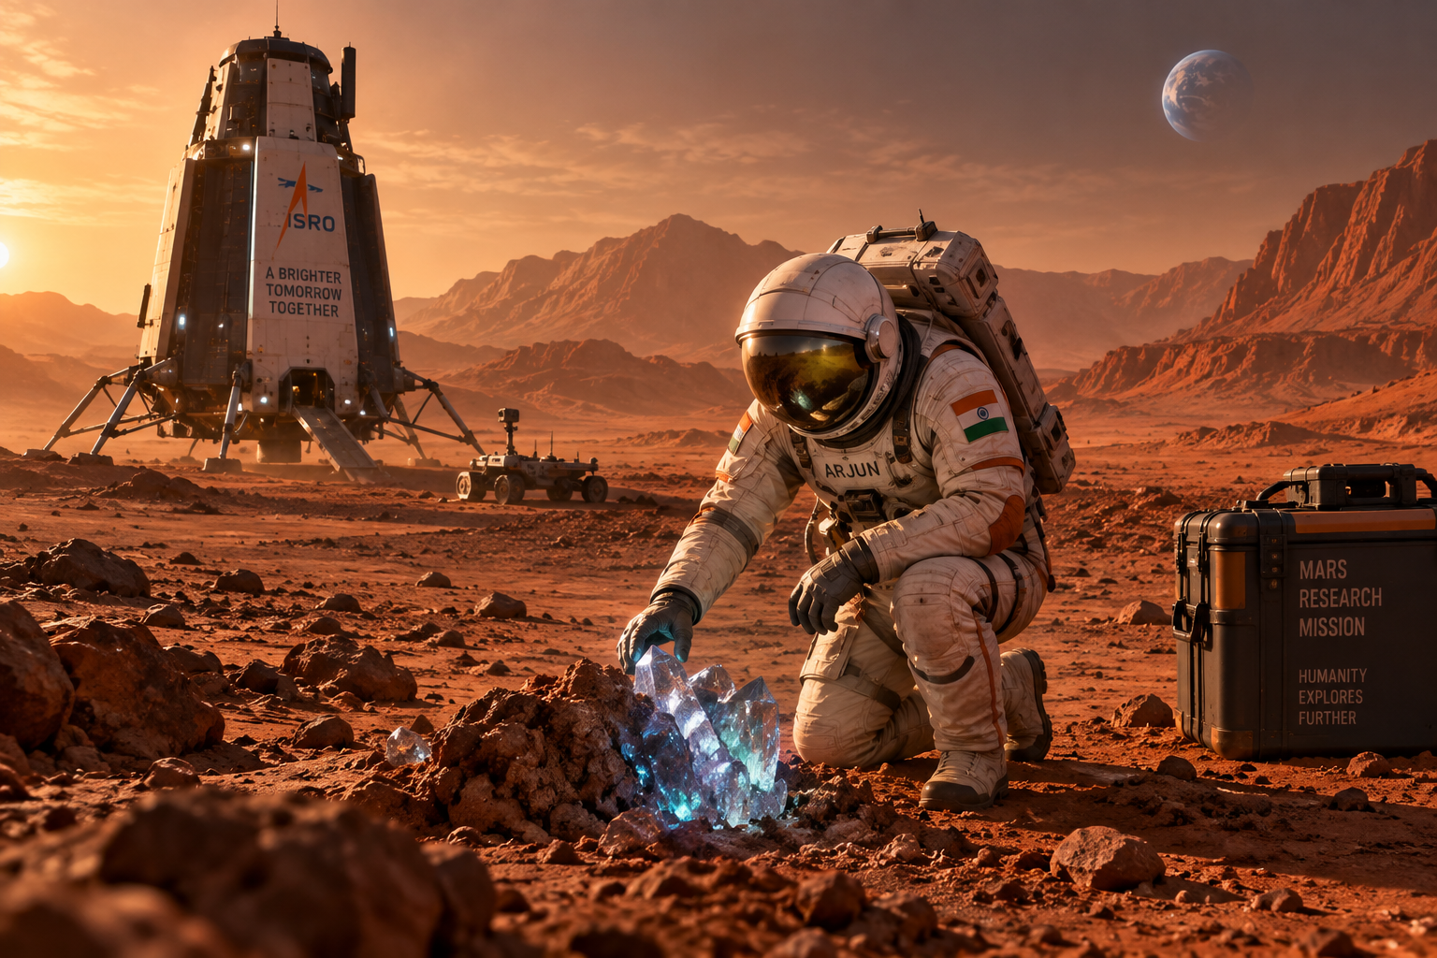
Figure 1: AI-generated image representing the Mars exploration theme.

7. Sound/Music Generation
Prompt Used
Generate a 20-second cinematic science-fiction background soundtrack for an astronaut's first exploration of Mars. Start with a slow, mysterious ambient sound representing the loneliness of space. Gradually introduce futuristic electronic tones as the astronaut explores Mars. Build toward a sense of wonder and discovery when the mysterious crystal is found. End with an inspiring and adventurous atmosphere. No vocals.
Audio file will be inserted by the student here.

8. Alignment Analysis
Element | Generated Output | Common Theme | Alignment
Text | Story about astronaut Arjun exploring Mars and discovering a mysterious crystal. | Mars exploration and discovery | High
Image | Astronaut exploring Mars and examining a glowing crystal. | Mars exploration and discovery | High
Sound | Cinematic soundtrack progressing from mystery to exploration and discovery. | Mars exploration and discovery | High
The three outputs are well aligned because they represent the same central theme—human exploration of Mars and the discovery of something unknown—through narrative, visual, and auditory forms.

9. Strengths of Multimodal Generative AI
- Creative content generation: AI can generate text, images, and audio from simple prompts.
- Multimodal representation: The same concept can be represented through multiple forms such as text, visuals, and sound.
- Time saving: Generative AI can create content much faster than creating each component manually.
- Easy customization: Prompts can be modified to change the generated output according to requirements.
- Improved user experience: Combining text, images, and sound can make content more engaging and expressive.

10. Limitations of Multimodal Generative AI
- Generated outputs may contain errors or inaccuracies.
- Image generation may produce unrealistic or incorrect visual details.
- AI-generated music may not perfectly match the intended mood.
- The quality of output depends heavily on the quality of the prompt.
- Different AI tools may interpret the same prompt differently.
- AI-generated content may lack the context and originality of human-created content.

11. Ethical Challenges
- Copyright and ownership: AI-generated text, images, and music may resemble existing copyrighted content, creating questions about ownership and attribution.
- Misinformation: Generative AI can produce realistic but incorrect or misleading text, images, and audio.
- Deepfakes and misuse: AI-generated images, videos, and audio can potentially be used to create misleading or deceptive content.
- Bias: AI systems may reproduce biases present in their training data.
- Privacy: Personal images, voices, or other private information should not be used without appropriate permission.
- Lack of transparency: It can sometimes be difficult to understand how an AI system produced a particular output.

12. Conclusion
Multimodal Generative AI was used to create text, an image, and sound based on the common theme “A Journey to Mars.” The three outputs were analyzed for alignment, and the strengths, limitations, and ethical challenges of multimodal Generative AI were discussed.

